Sarah Dye, President, presiding

Josefana Aleman Lori Macias-Clark
Mary Arndt Luis Martinez
Elizabeth Becker Loretta McCallister
Rick Bonnom Patricia O’Brien
Michele Brynelson Joel Peck
Julie Delong Mary Peterhans
Susan Ford Roger Ramey
Clark Hallpike Howard Russo
Linda Hefferin Manuel Salgado
Cindy Hutman Glenn Turner
Crystal Kerwin Scott Vaszily
Dan Kocher Vicki Walker
David Lawrence Cassandra Watson
Absent: Len Fitzpatrick, Marcia Luptak, Gary Norden

Meeting called to order by Sarah Dye at 3:07

Guests:

Secretary’s Report: Lori Macias-Clark
- Regular Meeting Minutes—November 17, 2010
  - Pat O’Brien motioned to approve the November 17 minutes. Luis Martinez seconded. Approved. 1 abstention.
Treasurer’s Report: Linda Hefferin
- Hefferin reported that she hasn’t paid dues because statement from IFT is messed up so looks like have more money than we do.
- Report accepted.

President’s Report: Sarah Dye
- Coming Events:
  - The ECCFA End-of-Semester Party Friday, December 10th at Carmina’s on Randall Road.
  - Annual Holiday Breakfast on the faculty’s contractually obligated Grading Day, Friday, December 17th starting at 7:30 AM.
  - Two faculty members are retiring—Tony Schuls, Professor I of Industrial Manufacturing Technology, and Laurel Vietzen, Professor II of Paralegal

1st Vice President’s Report: Luis Martinez
- See Negotiation Report

2nd Vice President’s Report: Susan Ford
- I am meeting with Bruce Austin this week to discuss the possible placement of tutors in the new UAF offices in MPC.
- Rose has approved additional load for UAs in Math and Biology for SP11. She has, however, denied additional load for several people in Art because she did not feel the dean’s reasons for it were justified. I had already given the ECCFA’s approval.
- The confusion about how to “count” semesters and years for UA2 qualification have been cleared up. It appears that 18 current UA1s will achieve UA2 status at the end of this semester. That would bring the UA2 group to a count over 200.
- We are keeping an eye on a perennial problem in one department where a very senior adjunct has been inactive because staffing is happening “too late” for this UA2 to select classes for a couple of semesters now. He contacted the dean and coordinator and received an unusual response. I have informed Tony Spahr, and he has informed Rose DiGerlando of the current situation.
- Questions:
  - Summer schedule assignments
  - Spring Schedule assignments
  - Fall schedule assignments
  - Leave—Sick Bank awards and extra pay assignments
  - Qualifications for hire
  - Summer/seniority

3rd Vice President’s Report: David Lawrence
- No Report
Committee Reports—

Academic Policy: Dawn Munson & Jennifer McClure
- No Report
Academic Technology: Dan Kocher & Mary Peterhans
- No Report
Achieving the Dream: Linda Hefferin & Sarah Dye
- Please continue to encourage your colleagues to become AtD champions! Send an email to Sarah Dye (sdye@elgin.edu) with the Subject line: “I Want to be an AtD Champion” to be added to our growing list. The AtD Champions list currently includes faculty, staff, and administrators:
- Faculty: Candy Moore, Marcia Luptak, Chalyce Deterding, Mary Peterhans, Elena Gardea, Beth Santell, Sumitra Duggirala, Dan VanTassel, Susan Timm, Celia Ramos, Lynn Ducar, Catherine Moushon, Joyce Fountain, Clark Hallpike, Dawn Munson, Shawn Mikulay, Stephanie Franco, Heidi Brelsford, Crystal Kerwin, Beth Santell, Patti Jachowicz, Sarah Dye, Linda Hefferin, Arturo Vasquez, Ron Kowalczyk, Roger Ramey, Cindy Hutman, Pat O’Brien, Maria Kazmi; Cassandra Watson, Michele Brynelsen, Dan Kocher, Dave Lawrence, Josefana Aleman, Mary Arndt, William Demaree, Jeff Weisman, Marta Walz, Tim Anderson, Michele Noel, Ruby Sanny, Rachael Tecza, Patrick Parks, Abraham Martinez-Cruz, Tammy Ray, Gary Norden (46)
- Staff: Stephanie Bonvallet, Phil Howard, Elaine Reid, Jacque Sweetman, Vany Wells, Kathy Meisinger (6)
- Administration: Sharon Konny, John Brzegowy, Kathy Stover, Wendy Miller, Margaret Parker, John Coffin, Sharon Colby, Kim Hinrichs, Annabelle Rhoades, Peggy Gundrum, Sandi Brown, Susan Scott, Marilyn Prentice, Julie Hartley, Bev Felder, Bruce Austin, Jorge Phillips, Debra Tewolde, Micaela Banks, Daysi Diaz-Strong, Erica Romano, Frank Hernandez, Deborah Wollenberg, Irina DelGenio, Julie Schaid, Michael Shepherd, Jennifer McClure, Kristin Richmond, Amybeth Maurer, Peggy Heinrich, Irene Birkholz-Benter, Tony Spahr, Susan Van Weelden, Jeffrey Arena, Lauren Nehlsen, Tammy Few, Holly Lawyer, Michael Shepherd, Heather Larkin, Kathleen Callahan, Rose DiGerlando (42)
- Carol Szabo is joining the Developmental Education Steering Committee. She will take on the role in January.
Alliance for College Readiness: Alison Douglas
- No Report
Amendments: Dan Kocher
- No Report
Assessment Committee: Shawn Mikulay
- No Report
BOT Finance Committee: Linda Hefferin
- No Report
- Will meet December 13
Communication Liaison: Gary Christenson
- Just want to remind people to read the "Dispatches," the ECCFA blog.
COPE: Ron Kowalczyk
- No Report
Curriculum: Maureen Lange
- The Curriculum Committee is meeting on Friday, December 3.
Elections: Bill Demaree
- No Report
Faculty Development: Beth Santell
- No Report
FAVs Dan Kernler
- The ECCFA food drive to benefit the Northern Illinois Food Bank runs Tuesday, 11/30 through the End-of-Semester party on Friday, 12/10. We will be accepting donations at locations around campus (see map on next page). We’ll also happily accept monetary donations. Checks should be made out to “NIFB” and sent to Linda Hefferin, ICT 213. We’re still looking for a couple more volunteers to help monitor boxes around campus and to load the truck at the conclusion of the drive.

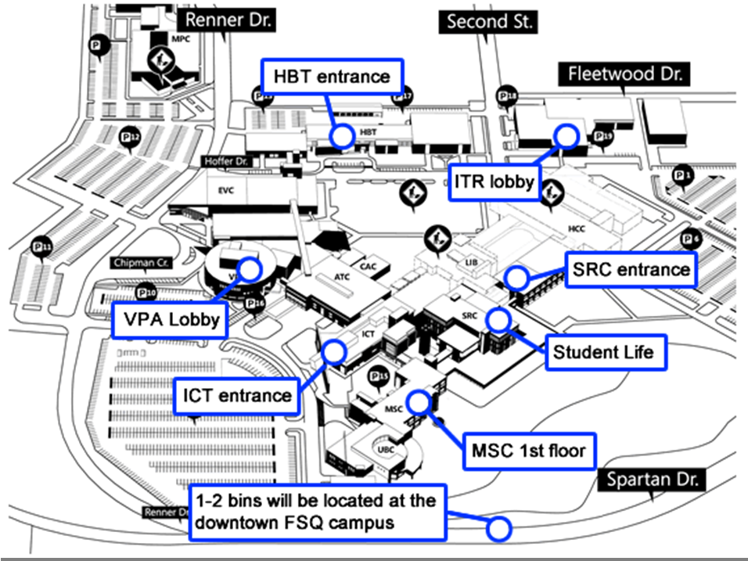

GIST David Burke
- No Report
Grievance: Howard Russo & Sue Ford
- We are still working on the final details for resolution to a disciplinary situation. It should be resolved by the end of the week.
- UA2 Qualifications: The misconception about applying contract language has been resolved. HR will be checking the records of the 61 UA2s who have qualified since Jan. 07 to find any who may have qualified sooner than reported. It will, of course, take some time.
- Substitute Pay: Howard, Sue and Roger met with Rose to determine a formula for the deans’ offices to use to calculate substitute pay. We have come to an agreement with Rose, and she is informing the deans. Tony Spahr and some employees in HR will be working with the deans to determine who was paid incorrectly since SP 09. There are over 1,000 instances of subbing during that time. That, too, will take some time to find and reimburse those who were not paid correctly.
Honors: Alice Biggers
- No Report
Humanities Center: David Burke
- No Report
Insurance Lynn Ducar & Vicki Walker
- No Report. Insurance Committee is next scheduled to meet Dec. 10

Learning Communities (Steering) Alison Douglas
- No Report
MAGIC: Kim Tarver & Clark Hallpike
- No Report
Membership: Connie Orbeta
Fall Semester 2010 – as of 09/28/10
- Full time faculty
  - 140 Members (4 non-members)
  - 144 eligible
- UA1s
  - 44 Members (132 non-members)
  - 176 eligible plus 10 INAs
- UA2s
  - 133 Members (51 non-members)
  - 184 eligible plus 5 INAs
- Total signed members 317
- Total 504 Faculty plus 15 INAs
Negotiations: Luis Martinez
Dear Colleagues,
It is the sincere hope of your Negotiations Committee that you have had a relaxing and enjoyable holiday break. We would like to express our sincere gratitude for the continuous support you have given us during these negotiations. We want to reaffirm our commitment to negotiate the best contract possible. Rest assured we have been working very hard to achieve that goal.
As you may have read on the Dispatches Blog on the ECCFA website, most of the non-monetary issues have been passed, and we will be moving into bargaining money issues very soon, hopefully this week. Still, progress could be made at a faster pace so that we can finish this negotiation process by the end of the semester. The ECCFA Negotiation Team is committed to finish the negotiation by the end of the semester.
By this email, the Negotiation Team is inviting all members of the ECCFA , Unit Adjuncts I and II and Full Time Faculty, to an informational meeting that will take place on Wednesday December 8, ATC auditorium at 5:00 pm,. At the meeting, we will inform the faculty about the status of the negotiations and of possible actions to be taken such as informational picketing and others.
Shortly we will start distributing "I support ECCFA" buttons as soon as the new buttons are ready. If you happen to have one from the last negotiation, please start wearing it. [Howard Russo will have them ready for Senators at this meeting.]
We need to display our unity and our support for the Negotiations Team and the ECCFA throughout the campus. Attached is a document with the “ECCFA Unity” sign. We are asking that this be posted on your office door.
Once again, our gratitude for your support and for everything you do for the college community.
In unity,
Luis Martinez
ECCFA Chief Negotiator
- Martinez encourages constituents to be at informational meeting.
- ECCFA support buttons have been made. There are 470 buttons, and senators have buttons to pass out to constituents. Faculty members are encouraged to wear old buttons too.

Scholarship: Bev Augustine
- No Report.
Sentinel: Bill Demaree
- The last issue of 2010 is scheduled for Tuesday, 7 December; this means I need all articles by Friday, 3 December.
Sick Bank: Ellie Swanson
- No Report.
Strategic Planning Committee: Elizabeth McNulty & Phil Garber
- No Report
Webmaster: Tammy Ray
- ECCFA Blog – The ECCFA Blog, Dispatches, has a link on the ECCFA Web site home page. The blog may also be accessed by going to http://eccfaculty.org/blog.
- Senate Agenda & Minutes – Most recent agenda and approved minutes are posted at http://eccfaculty.org/minutes, when they become available.
Other Committees:

Special Orders:
Approval of committee members (treat as Consent Agenda)

Old Business:
Catering Issues—
- Peter (asst. director) is aware of the issue and asked for our help in alerting them to when the problem occurs; he suggested that faculty call the catering office if they discover old dishes in their classrooms and that those placing catering orders indicate specifically when the food service for the event should be picked up so as to not disturb a group using the room afterwards.
- When go to classroom call catering and tell them stuff is sitting there and ask to come and get it. It was also suggested that when order goes in the person placing the order should tell when meeting will be done because they will go and pick up the items.
- Ford said a problem with this was if it is a night class, no one will answer the phone. Can we talk to Peter or Maria on suggestions on what to do for night class?
- Martinez suggested that when order is placed, whomever is placing it should tell when meeting is over, so items can be removed.
- Dye said she will encourage those placing orders to let Catering know the ending time.
Early alert—
- Dye talked to Wells. Rick said get reports directly through Datatel and not through one person. Dye will check on the matter again with Dr. Cowles.
End-of the Semester Party—
- The Invitation went out yesterday. Martinez and Dye talked about appropriateness of having a party in light of what we have to do in regards to negotiations. Should we go ahead?
- Martinez said the issue is not having the party; the issue is whether we should have a party with the administration when we don’t have a contract
- Ford commented that we should still have the party. Even though there may be tension at table, there shouldn’t be any in the halls or in a restaurant. We have to work with these people every day. For the most part, our relationship, in general, is better than she remembers it being. WE want to make sure we keep that. Negotiating is work we have to do together. It’s not about us. The party depersonalizes the situation
- Russo said that he agrees with Ford. We have to put aside the issues at the table and not take it personally
- Bonnom said that by having it, we’re showing we can be above it.
- Kocher agreed, saying it’s a matter of professionalism with negotiations. This is a tense situation, but we have to be able to leave it at door. If we avoid contact, it will cause problems after negotiations. We can wish them happy holidays
- Dye said she will send out invitations tomorrow.
New Business:
Preparation for Job Action—
- Next week we will meet with all of the faculty, and Martinez will explain what state we’re in at that time, and we will make decision as faculty on how to move forward. Sometimes you begin certain steps and make certain people know that you beginning to take those steps. One of steps that needs to be taken is to form job action committees.
- Sarah Dye passed around a clipboard, and Senators were asked to make choices about what committees they have preference working on. Everybody is expected to do their part. If we keep getting further, we will have a handbook for faculty indicating times and places to march. We should appear at next Board of Trustees meeting onTuesday, December 14 at 6:30. We usually do informational picketing outside the meeting, outside the buildings. We do a lot to protect non-tenured faculty.
- Ramey said he had talked to talked to Kim Tarver and the two of them would like to head strike headquarters.
- Russo said that strike headquarters would be at the labor temple
- Hutman said we need have chair-people down before we can start talking too many details
- Russo commented that we have strike signs prepared and have stencils to make more signs
- Hutman asked if an email go out about board meeting
- Dye said that Len Fitzpatrick and Gary Norden will serve on the transportation committee. She also said that volunteering on these committees and being involved during negotiations is an opportunity for everyone to get involved with the ECCFA and a way to feel like a true part of the union
- Ford asked Lynette Scaluca, our IFT rep, is working to file the appropriate
- Hefferin said, yes, the 45 day notice has to be filled out before December 25
- Martinez asked if heshould send email about board meeting before or after faculty meeting?
- Hutman expressed concern about people who will need to adjust schedules. If we send a notice out, people will be more likely to be here next Wednesday for the informational meeting.
- Lawrence reminded faculty members that they can’t miss office hours, but they can change them as long as the dean and students know that the hours are changing.
- Russo said the best thing to do is be prepared to have job action.
- Martinez—said thank you for support. The meals are fantastic. There are more meetings to come. any way you can help is appreciated. Cash donations are accepted. Contact Armando Trejo and Mary Elfring.
- Becker said to let us know when the team wanted us to sit in the hallways and show support.
- Ford said when the faculty does that it gives the team energy and intimidates the administration a little bit.
- Hefferin said it also shows that the faculty are behind the team.
Job Action Committees:
- Strike Preparation Steering Committee
- Informational Picketing Committee
- Communications Committee
- Community Committee
- Welfare Committee
- Strike Headquarters Committee
- Transportation Committee

Adjournment:
- Howard Russo motioned to adjourn. Luis Martinez seconded. Approved. Meeting adjourned at 4:12 pm

Respectfully submitted by Lori Macias-Clark, ECCFA Secretary

